**CE101 Engineering Drawing July- Nov 2019**

**Indian Institute of Technology Guwahati**

**Lab Sheet-3 Orthographic Projections Tuesday Morning**

**Max Marks: 90 + 10 (overall neatness) Date: 27.08.2019**

Draw the **FV, TV and LSV** for the following objects provided.

**Unless otherwise mentioned, use the First Angle Projection method.**

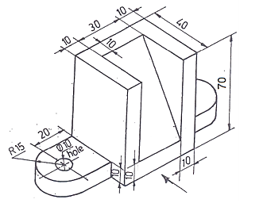

1. **[30]**

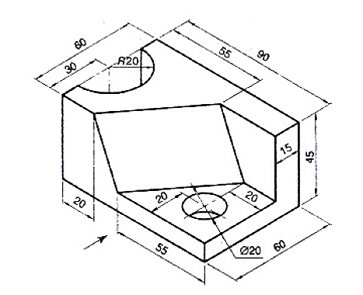

1. **[30]**
2. **Use Third Angle Projection Method [30]**

